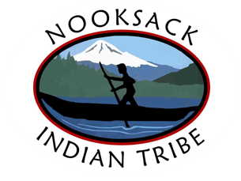  Young adults 16-24 Info Session Come check it out!! March 19th from 3 pm-5pm in Building G at the Timber Ridge Location  Struggling with next steps after high school???  Check out this information session!  What does the Nooksack Tribal Emerging Adult Program Provide?  - One-on-one academic support  - Assist with expenses related to school or job training  NW Workforce Council collaboration can hook you up with more incentives $$$  - Workforce will have a presentation about the incentives they provide when you complete different skill-building trainings.  After info session is over we can help with registering for the program  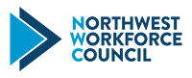 | HS Diploma & GED completion incentives $$$  ____  Up to $9,000 scholarship!  ____  Resume writing, skills training, tutoring  ____  Paid Internships and pre-apprenticeships  ____  NIT Emerging Adult Program support  Nooksack Tribal Youth porgram  5604 Mission Rd  Bellingham, WA 98226  360-966-9696  ntussey@nooksack-nsn.gov  https://nooksacktribe.org/departments/education/  Nadine Tussey, M. ED Academic Intervention Specialist

